1. Click the link for the assignment you need to submit. (Look under Submission of Assignments.)   
   (Note: you will submit Assignments 1, 3, and 5 once only. Your tutor may ask you to re-submit Assignment 2 and/or Assignment 4. Moodle will allow two submissions for each of these assignments.)  
   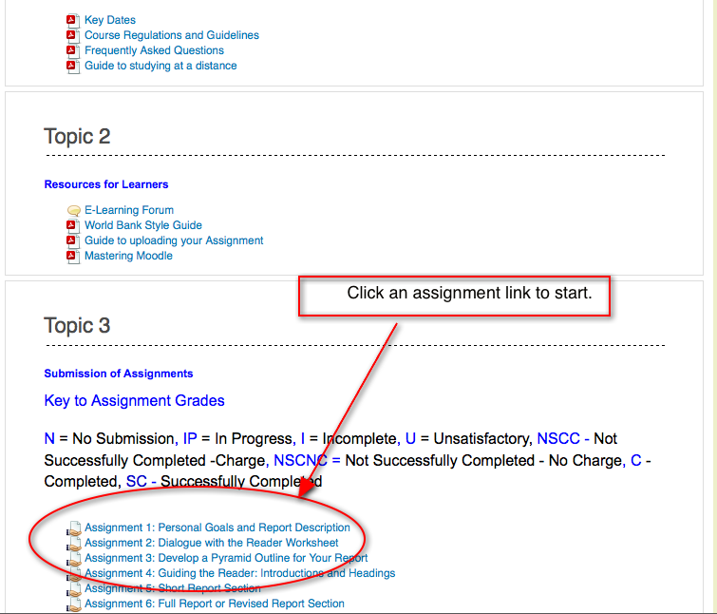
2. Click the “Upload files” button to open the empty file submission window.   
   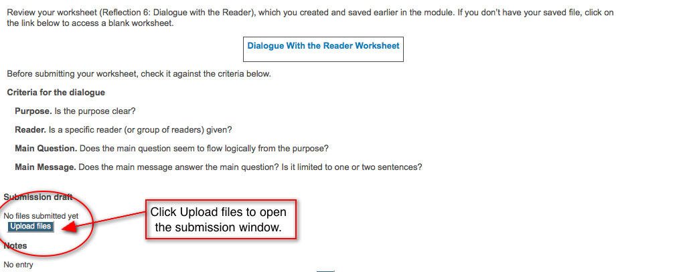
3. *To drag and drop files* into this window, click on the name of your completed assignment file(s) (hold down the “shift” key to select multiple files), then drag the icon(s) across your screen and into the submission window.   
   (Note: the “Maximum size for new files …” note above the submission window will tell you if drag and drop is available with your browser.)

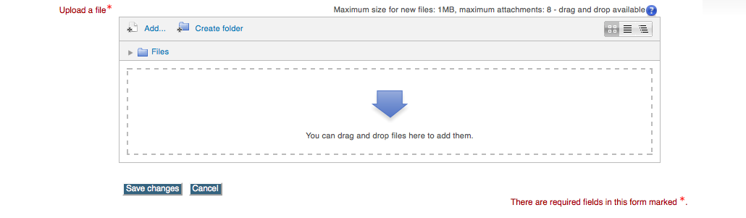  
 *To upload files manually*, click “Add” and a “File picker” window will appear:  
Click “Browse” and select the file from your computer to be uploaded.  
Click “Open.”  
Click “Upload this file.”  
Click “Add” again, and repeat this process until you have all the required files uploaded.

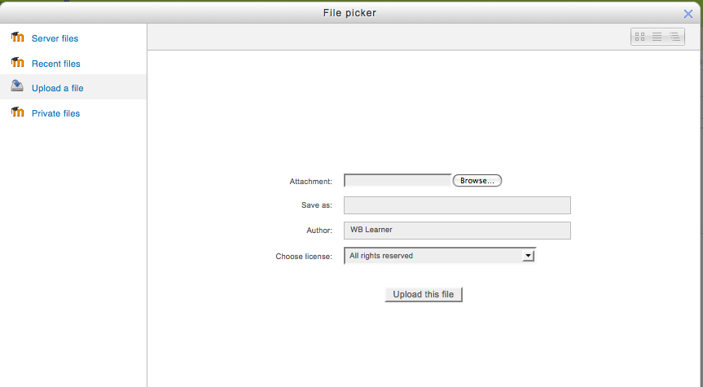

1. You may review your uploaded assignment files by clicking on the individual file icons in the submission window. If you are not satisfied with an uploaded assignment file, you may delete it and upload a replacement.   
   *To delete a file*, click on the file icon and then click the “Delete” button in the pop-up window that appears.
2. Click “Save changes” when you are ready to finalize your assignment submission.   
   At this point, your assignment submission is still considered a draft. You may click “Edit these files” to return to the submissions window to delete or add new files.   
   **Once you click the “Send for marking” button, the assignment is locked for marking and you will not be able to make further changes.**

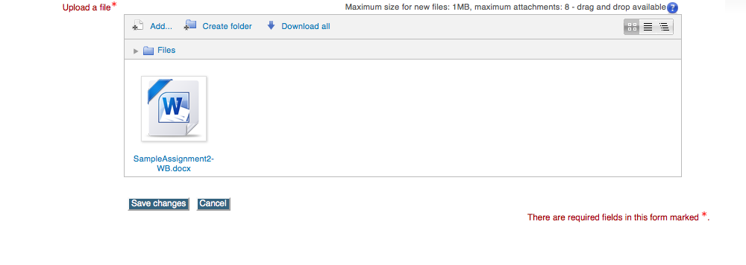

1. Click “Send for marking” and then “Continue” when you are satisfied that your uploaded files are ready for marking. This completes the submission process and notifies your tutor that your assignment files have been uploaded and are ready for marking. (Note: if you do not click on “Send for marking,” the system will not register your submission and your tutor will not know the assignment is available for marking.)

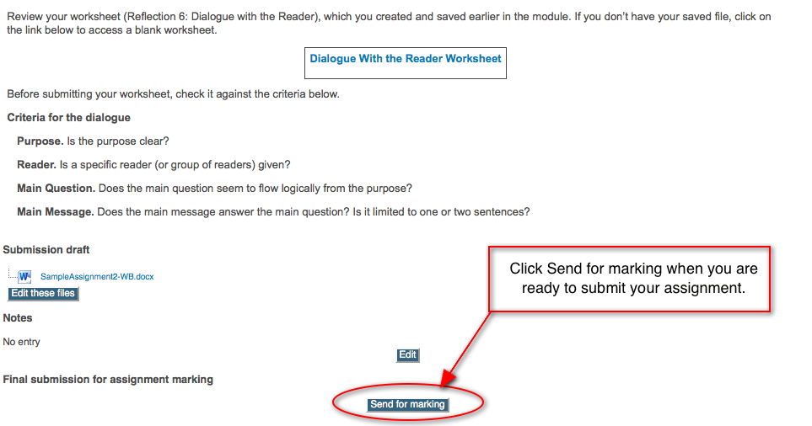

**File format and naming requirements:**

* Assignment files must be in MSWord format.
* The maximum file size per upload is 1MB. MSWord files are small, so your file sizes should be much smaller than this.
* Use the following file naming convention for your assignment files:   
  last name_M1Ass1sub1 (for example, “Murray_M1Ass1sub1”).